

**Department of Computer Engineering**

**Academic Year 2025-2026**

**“Abhiyanta” Newsletter**

**For Odd Sem, Volume 3**

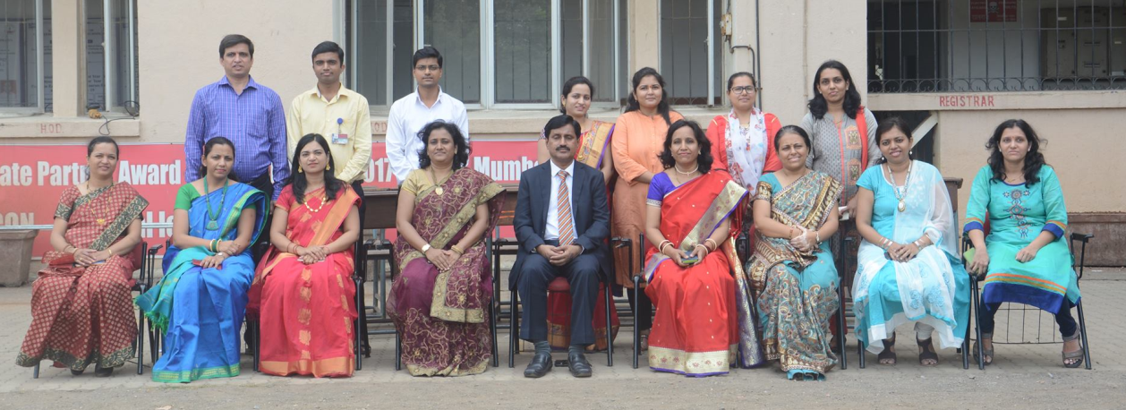

**About Department:**

The Computer Engineering department was established in the year 2001 for providing excellent education to all students with an aim to foster creativity in Learning, research and building a knowledge base along with imparting quality education. The department possesses well qualified and motivated faculty members and support staff. The laboratories are adequately equipped with state-of-the-art facilities. The department offers add-on courses to cope with the latest trends in technology. It organizes industry visits and many series of expert lectures for the students on the latest developing trends in Computer Industry. Students of our department have won prizes in various national and international level paper presentation competition and project exhibitions. Every year a remarkable number of students place in companies such as Infosys, TCS, Accenture, Cognizant, L&T Infotech, CSC, Tech Mahindra, Mastek, TPG Axon, Artistivity etc.

**Vision:**

*To be the finest centre of learning by imparting quality teaching in the field of computer engineering*.

**Mission:**

* *To inculcate in student the ability to analyse, design and develop software projects.*
* *To prepare students to be ready for ever changing scenario in the field of Computer Engineering.*
* *To help the students to attain and utilize their potential for successful carrier and to the need of society and industry.*

**Program Educational Objectives (PEOs):**

Students will possess:

PEO I: *Sound knowledge of mathematics, science and engineering fundamentals required for a lifelong career in computer engineering domains.*

PEO II: *Skill to design and develop software projects for solving real world problems with the use of modern tools and techniques*.

PEO III: *Professional ethics, leadership qualities and social awareness in the students.*

**Highlights of the Department**

 Lorem ipsum dolor sit amet, consectetur adipiscing elit. Curabitur pulvinar dignissim ex.

 Donec nunc leo, accumsan pretium nisl ac, bibendum fringilla ligula.

 Aliquam erat volutpat. In eget facilisis orci. Aenean iaculis euismod nulla, nec convallis diam ornare volutpat.

**Remarkable Milestones**

 Curabitur venenatis, nibh quis pharetra tincidunt, odio nisl sollicitudin justo, vel efficitur odio urna eu libero.

 Praesent id urna arcu. Curabitur ultricies enim ac sapien dictum, non lacinia metus tincidunt. Nulla tellus urna.

 facilisis sit amet augue eu, semper imperdiet nisi. Nulla quis porta tellus, sit amet ornare nunc.

|  |  |
| --- | --- |
|  |  |
| **Heading of Pic 1** | **Heading of Pic 2** |
|  |  |
| **Caption of Pic 1** | **Caption of Pic 2** |
| **Heading of Pic 3** | **Heading of Pic 4** |
|  |  |
| **Caption of Pic 3** | **Caption of Pic 4** |